## Nielsen Heuristics Evaluation Form (make as many copies as you need)

**1. What screen of the UI are you looking at (attach/paste a picture/screenshot):**

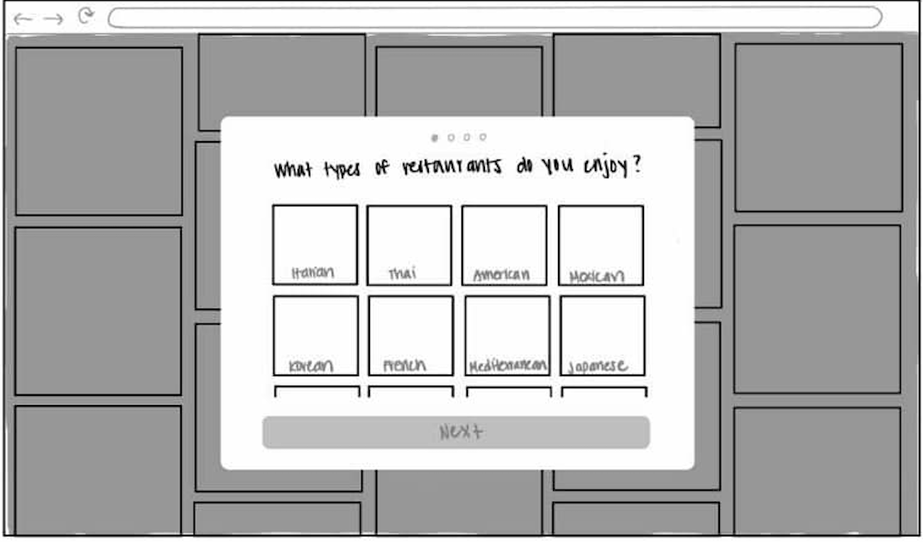

**2. Evaluate each heuristic below for this screen. Feel free to draw circles and arrows around the above screen shot.**

* Visibility of System Status:

**The users can see that the system provides a clear prompt ("What types of restaurants do you enjoy?") and a visual indication of their progress through the task (via the progress dots at the top). However, there is no immediate feedback when users interact with the options.**

* Match Between System and Real World

**The system uses categories familiar to users (e.g., "Italian," "Thai") that match real-world concepts. However, it lacks a natural, conversational tone that would make the interaction more engaging.**

* User Control and Freedom

**Users can select options, but it’s unclear if they can deselect or undo a choice. There is no visible "back" button or clear way to skip the task if desired.**

* Consistency and Standards

**The design appears consistent in presenting categories as selectable tiles. However, it is unclear whether the "NEXT" button is always available or only activates after making a selection, which could affect consistency.**

* Error Prevention

**The system minimizes potential errors by using clear, distinct tiles for selections. However, it is not apparent if there is confirmation for selections or prevention mechanisms for accidental clicks.**

* Recognition Rather Than Recall

**The design supports recognition by displaying all options visually rather than requiring users to recall restaurant types. This helps reduce cognitive load.**

* Flexibility and Efficiency of Use

**The interface appears designed for novice users, but it lacks shortcuts or advanced options for experienced users who might want to type in preferences or bypass the task altogether.**

* Aesthetic and Minimalist Design

**The design is clean and uncluttered, with a focus on the task at hand. The simplicity supports usability, though it could feel overly stark or lacking personality.**

* Help Users Recognize, Diagnose, and Recover from Errors

**There is no visible mechanism to guide users in diagnosing or recovering from errors, such as selecting the wrong option or experiencing technical issues. The system could benefit from error messages or instructions for troubleshooting.**

* Help and Documentation

**The current design lacks any visible help or documentation features. Users are not provided with tooltips, guidance, or instructions beyond the main prompt ("What types of restaurants do you enjoy?"). If users encounter confusion or difficulty, they have no immediate way to seek assistance within the interface**